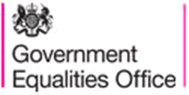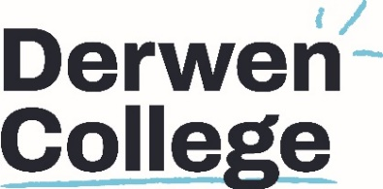

Gender Pay Gap Submission

Derwen College is required by law to carry out Gender Pay Reporting under the Equality Act 2010 (Gender Pay Gap Information) Regulations 2017.

Derwen College has carried out calculations and our gender pay gap data for 2021 is as follows

• The mean gender pay gap – 6.8%
• The median gender pay gap – 11.7%
• The mean bonus gender pay gap - n/a as we do not pay bonuses
• The median bonus gender pay gap – n/a as we do not pay bonuses
• The proportion of males receiving a bonus payment – n/a
• The proportion of females receiving a bonus payment – n/a
• The proportion of males and females in each quartile band:
    - Lower Quartile 28% Men and 72% Women
    - Lower Middle 16% Men and 84% Women
    - Upper Middle 20% Men and 80% Women
    - Upper Quartile 28% Men and 72% Women

These results have been submitted to the Government Equalities Office aswell as being published on our own website.

We can confirm the gender pay data is accurate.

Kind regards

The Leadership Team

